Question 1: (4.0 Point)
Design the form might look something like figure below, named the java file is AEdit.java (0.5 Point)
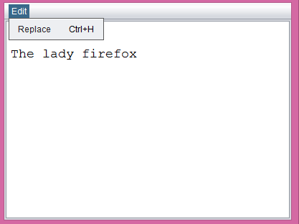
The Frame includes a menu bar with a menuitem (Replace, shortcut key included) and a textarea, “the lady firefox” is default value of textarea.
If users select Replace, show a Replace dialog form which might look something like figure below (0.5 Point)
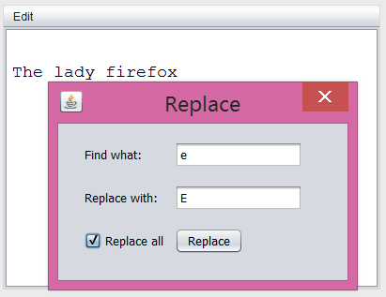
txt1
txt2

When users enter values for txt1, txt2 and click on Replace button, find the characters in textarea which is equals to txt1 and replace by txt2. Replace the first occurrence if checkbox Replace all is unchecked (1.0 Point) otherwise replace all occurrences (1.0 Point).
